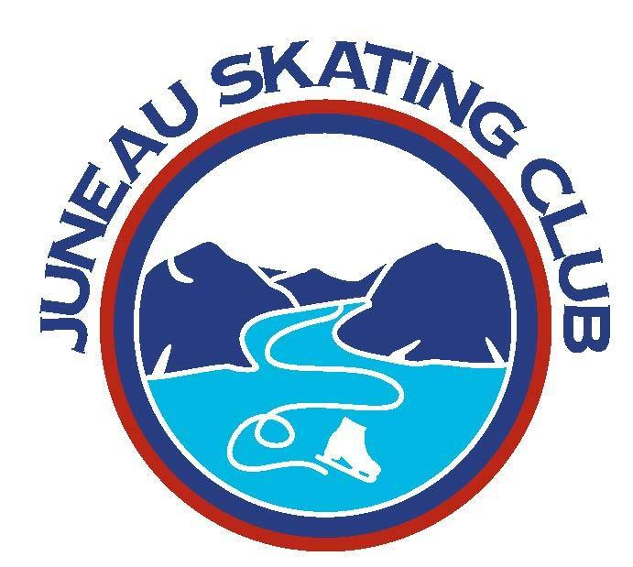
Juneau Skating Club
Board of Directors Monthly Meeting
July 15th, 2025 6:00 p.m.

Downtown library small conference room; Zoom option
Join Zoom Meeting
https://us06web.zoom.us/j/86024555273?pwd=Q4a1IrlKBxYy75oucHuGrGD3nNymy4.1

Meeting ID: 860 2455 5273
Passcode: 303817

Attendees: Pam, Jenny, Niamh, Meredith, Lauren, Andrea, Mary
Guests:

Start @ 6:00 pm
- Approval of June Minutes
Jenny motioned to approve, Lauren seconded. Motion passes.
- Approval of the July Agenda
- Reports
  - Rink Manager’s Report
- Meredith provided update from Nate. He needs our certificate of insurance ASAP. Starting to plan scheduling for the rink from January to close.
  - President’s Report
- USFS renewals for coaches and board members were completed.
- The board held work sessions over the weekend with participation from JSC coaches, and discussed priorities for the coming year, including increasing community presence through increased outreach, improving rink visibility, and enhancing the financial stability of the club through fundraising.
  - VP’s Report
- Email vote on membership fees passed. Fees will increase incrementally to cover increases in USFS fees.
- Discussion of USFS membership. Decided to keep memberships attached to program purchases rather than making them a standalone product. Discussion of who needs to get USFS memberships. JSC membership should be required for all figure skaters. Discussed anyone, including adults, skating on club ice or a JSC figure skating class needs to have a USFS membership.
  - Treasurer’s Report
- Mary made a new motion to add Niamh Dardis as a bank account signer and remove Melissa Fritsh and Tracy Maxwell. Meredith seconded. Motion passes. Regarding authorized signers on our other bank account, the bank can’t tell us who the authorized signers currently are, so Mary will call who she thinks might be and have them call the bank.
  - Skating Programs
    - LTS
- No updates
    - Figure Skating
- Off-ice activities have not been well attended, but will continue as planned through the summer.
- Upcoming competitions are November 7-9 TFMN in Irvine; Jan 22-25 TFMN Pacific Coast Sectionals, maybe in Colorado; Feb 13-16 ISI Winter Classic in Valencia, CA whole club and synchro teams; Arctic Winter Games March 8-15 Leah and Muriel might be coaches. Application process to participate.
- The winter classic needs to be communicated and advertised early to the club

- Old Business
  - Committees
    - Performance committee - Niamh, chair
    - Test committee - Niamh, chair
    - Marketing/Outreach - Jenny, chair
    - Fundraising - Andrea, chair
    - Safety - Jason, chair
    - Scholarship - Niamh will check with Michelle V.
    - Meredith will follow up with committee chairs
    - Volunteer email will be sent out early in the season about volunteer requirements and opportunities

  - Fall clinic
    - August 22-24, Mark Jaehnke will come up from Seattle
    - Will be sessions for adults and 2 groups of youth skaters. “High” will be for any skaters in pre-preliminary or higher, “low” will be for skaters who haven’t tested yet or are in advanced basic skills.
    - Friday afternoon session will be for youth only and covered entirely by the youth activities grant. Needs to be made clear in advertising
    - Preliminary estimates of cost based on 24 youth will be $120 for the “high” youth group; $100 for “low” youth; $60 for adults
    - Detailed email with information about the clinic schedule will be sent closer to the clinic and a save the date will be sent shortly.
    - Meredith will get the clinic in the system as two separate registrations, one for Friday afternoon and one for the rest of the clinic. Someone will need to be there on Friday and make sure everyone has registered, even though it will be free. Mary and Naimh will work on a detailed email about registration.

  - Handbook
    - Discuss at August meeting
    - Will be an email vote happening shortly
    - Needs to have a section added covering competition and payment policies, especially how the club splits costs; suggestion: require a $100 down payment at registration time
    - Also needs a section about outstanding invoices

  - YAG and synchro invoices
    - Mary will take care of in near future

  - Testing costs
    - Discuss at August meeting
    - There are costs associated with ISI testing. To date, we haven’t charged it. There is an additional testing fee option in Uplifter - what is that?

  - Back to the rink event
    - Plan for 1-3pm Sunday August 24. Youth will skate until 1215, adults finish at 2. Should allow both groups to attend
    - Lauren will reserve the one of the shelters at Sandy Beach
    - Will be a potluck - potentially make a sign up list for food?
    - General JSC event, not just clinic
    - Invitations need to be sent out
  - To-do list from May meeting

- New Business
  - Collecting on unpaid invoices
    - Will continue attempting to get actively skating families to pay any unpaid invoices
    - Potentially write off unpaid invoices of former skaters after two years

  - LTS Instructor Pay
    - Motion made to increase LTS pay by $5/hr
    - What would a $5/hr increase look like financially for the club for a season?
    - Everyone who teaches LTS classes gets the same $20/hr
    - Teaching figure skating classes is $40/he
    - Individual coaching fees can be different - relatively recent development
    - Should revisit pay on some regular schedule
    - Motion tabled. Will revisit in August
    - Need to clarify the distinction between instructors, assistants, and helpers
    - Niamh will find out from Emily who all the LTS instructors are and we can figure out what the difference in costs will be based on previous years’ numbers
    - Past LTS instructors that could be reached out to to teach: Susan, Melissa Fritsch
    - Potential for the new rink Program Coordinator to teach?

  - Volunteer requirements
    - Motions made and passed that resulted in a requirement of 10 hours volunteer time per family at level 1 or 2 memberships, with a $20/hour fee for unmet hours at the end of the season. This requirement includes adult skaters who skate on club ice (who should have a USFS membership).

- Next Meeting:
  - Tuesday 8/19 6pm location TBS

